**DORMAEL LOUIS Instructions for using linux**

**BERTOUT BAPTISTE**

**DESMONS HUGO**

In this manual, we will see the different uses and functionalities of linux that you can perform in a terminal.

A terminal is a command prompt, it allows you to type commands in a non-graphical way. That is, we type what we want to do ourselves.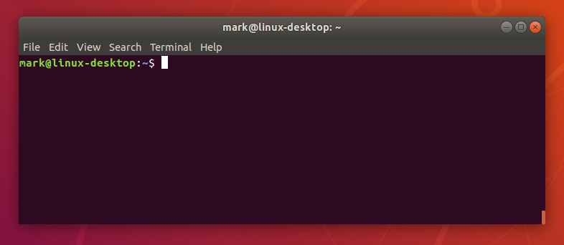

To open a terminal under Linux, press simultaneously : Ctrl + Alt + T

**_________________________________________________________________________**

Login as "root" using the command (if you know the root password): su root

You can give sudo rights to the user you want with the command: usermod -aG sudo [username].

The sudo rights allows the user to execute commands as a super-user.

**_________________________________________________________________________**

Under linux we can manage users, passwords, groups and rights.

Managing users :

To create a new user :

* useradd [name]

To delete a user :

* userdel [name]

Groups management:

To create a group:

* groupadd[groupName]

To add a user to a group:

* adduser [name] [groupName]

To remove a user from a group:

* deluser [name] [groupName]

To delete a group: s

* groupdel [groupName]

Password management :

To change the password :

* passwd [name]

Rights management :

To change the owner of a file :

* chown [file] [new owner]

To change the rights on a file :

* chmod [u/g/o] [+/-] [r/w/x] chown [file]

u= user; g=group; o=other / +=add; -=remove / r=read; w=write; x=run

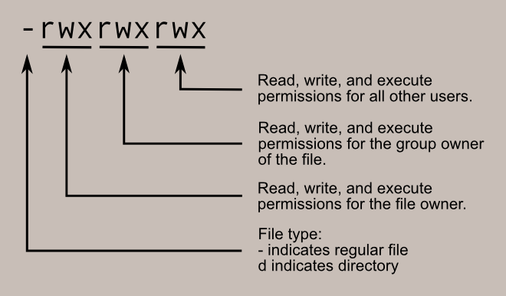

Under linux, we can also manage the installation and uninstallation of applications by command line.

Application management :

To install an application whose packages are located on a mirror site (a site where all the packages needed to install the OS are located) of the operating system you are using (such as ubuntu, debian, etc):

* apt-get install [application] (example: apt-get install firefox-esr)

To install an application whose packages are not on a mirror site:

install the package on the internet with the corresponding extension (example: package.deb for debian)

* dpkg [path to the downloaded package].

To remove an application :

* apt-get remove [application]

To replace the mirror:

* nano /etc/apt/Source.list
* Replace the used mirror by the desired one
* then : apt-get update

Additional configurations:

To know how a command can be used you can ask for help by running the command:

man [command name]

This manual is probably in English, to put it in French :

* dpkg-reconfigure locales

To change the geographical zone to change the time zone :

* dpkg-reconfigure tzdata

To change the keyboard mode temporarily (the time of the session) :

* setxkbmap [fr / us] ( fr for azerty and us for qwerty)

To change the keyboard mode permanently :

* dpkg-reconfigure keyboard-configuration
* configure the way you want

You can partition your disk to assign the folders you want, and facilitate the organization of your file management.

Partition management:

To partition disks, Fdisk :

* Fdisk -l ( allows to see the partitions )
* Fdisk /dev/[disk you want to partition]

For any doubt, enter m (m=help)

* in the fdisk menu : enter n (n = new partition)

or enter d (d = delete a partition)

* Enter "+" [value] [G/M/K] (G=go/M=mo/K=ko)
* enter w (w=save)

Management of formatting:

To format a partition:

* Mkfs -t [format] /dev/[partition name+number]

To mount a partition (to be able to access it more easily) :

* Mkdir [name we want to give to the partition (here we will call it part1)] [path to the place where we want to mount the partition (here we will call it home)]
* mount -t [format of the partition] /dev/[partition] /home/part1

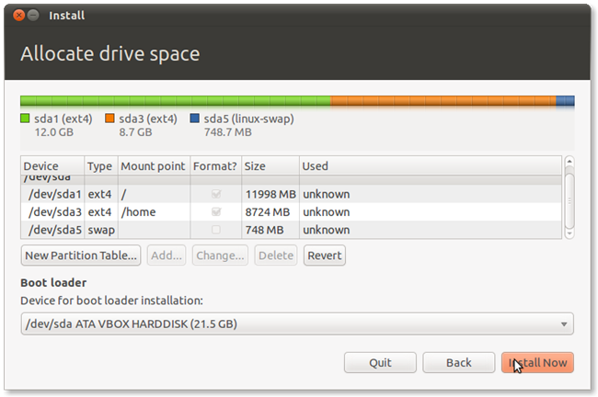

*this document contains 564 words*